CSE241 HW5 REPORT – Atakan AKDOGAN 1801042612

In this Homework, I have 1 Abstract Class and 3 Inherited Class. These are:

1-BoardGame2D: 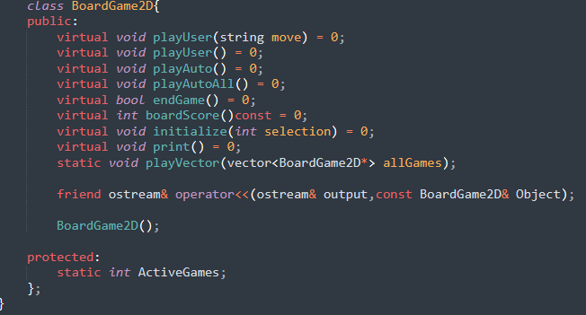

2- PegSolitaire,EightPuzzle and Klotski:

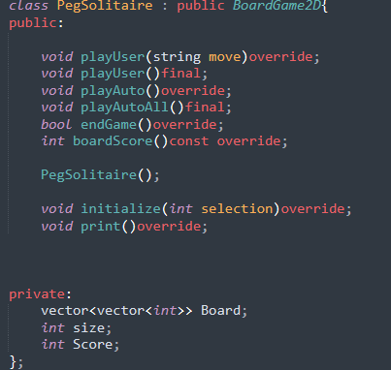

The inherited class implementations were same. Their initializations,controls,prints .. were different.

I wrote all of explanations in their own cpp files.

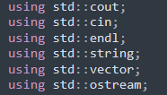 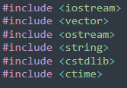

I used them for my functions.

I want to show some playings.

1-PegSolitaire:

playUser->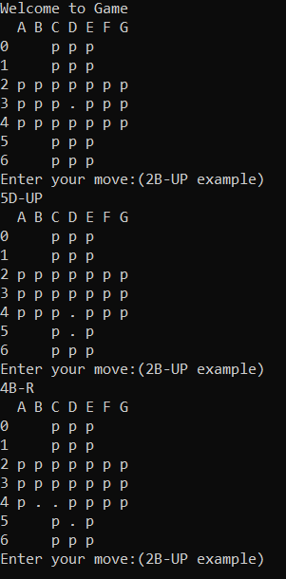playAutoAll->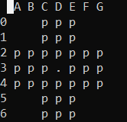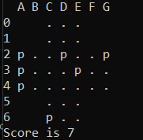

2-EightPuzzle:

playAutoAll->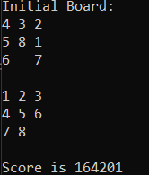playUser->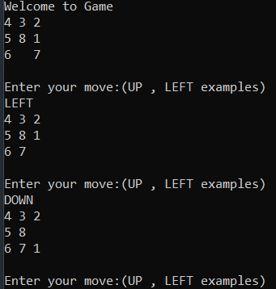

3-Klotski:

playAutoAll->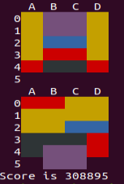playUser->